IoT-Based RFID Attendance System with Google Sheets Integration:
INTRODUCTION:
This project is an IoT-based digital attendance system using RFID technology and cloud connectivity. RFID attendance system combines multiple technologies for comprehensive employee tracking. When an RFID card is scanned, the Arduino plays a personalized welcome sound via DFPlayer while displaying the name on an LCD. Simultaneously, the ESP32 transmits the data to Google Sheets via Wi-Fi for cloud logging. The system provides immediate audio-visual feedback while maintaining secure cloud records. It's designed for corporate environments needing interactive, reliable attendance management with instant confirmation..

ADVANTAGES:
- Interactive audio feedback for user confirmation.
- Visual display of check-in status.
- Real-time cloud synchronization.
- Dual-microcontroller fault tolerance.
- Personalized welcome messages.
- Timestamped cloud records accessible anywhere.

LITTLE WORDS ABOUT MY PROJECT:
This system greets employees by name when they check in, providing both audio and visual confirmation. Their attendance is immediately logged to Google Sheets with exact timestamps. Using separate controllers for input/output and networking ensures stable performance. Tested in office settings, it reliably handles multiple check-ins with instant cloud updates.

Table of Contents
- How the Interactive Attendance System Works
  - └ RFID Scanning & Processing
  - └ Audio-Visual Feedback
  - └ Cloud Data Transmission
- Components Required
- Circuit Connection Diagram
- Hardware Setup & Level Shifting
- Google Sheets & Webhook Setup
- Arduino & ESP32 Code Implementation

How the Interactive Attendance System Works:
1. RFID Scanning & Processing Stage
This is the first stage where the system identifies who is checking in. The MFRC522 RFID reader constantly sends out radio waves. When an employee brings their RFID card close (about 5-10 cm), the card gets power from these waves and sends back its unique code (UID).
The Arduino receives this code and checks it against a stored list of authorized employees. Each employee's card has a different UID linked to their name and a specific welcome audio file. If the card is recognized, the system moves to the next stage. If not, it shows "Unauthorized" on the display.
2. Audio-Visual Feedback Stage
This stage gives immediate confirmation that the check-in was successful:
For Audio: The Arduino tells the DFPlayer Mini module which audio file to play. The DFPlayer reads the MP3 file from the memory card and plays it through the speaker. Each employee hears their personal welcome message (like "Welcome, Rajesh").
For Visual: At the same time, the 16x2 LCD display shows the employee's name and check-in time. The display updates within milliseconds and shows information like:
- First line: "EMPLOYEE CHECK-IN"
- Second line: "RAJESH - 09:45 AM"
Both audio and visual feedback happen together, so the employee gets confirmation through two senses - they hear their name and see it on screen.
3. Cloud Data Transmission Stage
While the employee is hearing and seeing their welcome, the data is simultaneously being sent to the cloud:
The Arduino packages the employee's details (name, ID, timestamp) and sends it to the ESP32 via serial communication. Since Arduino uses 5V and ESP32 uses 3.3V, a voltage converter is used to protect the ESP32.
The ESP32 connects to the office Wi-Fi and sends the data to Google Sheets using an internet connection. It makes an HTTP POST request to a special web address (webhook) that's connected to a Google Sheet.
In Google Sheets, a custom script receives this data and automatically adds it as a new row in the attendance sheet with all details: exact timestamp, employee name, ID, and check-in status. This happens in real-time, so the attendance record is updated in the cloud within seconds of the RFID scan.

BOM:
- Arduino UNO
- ESP32 DevKit v1
- MFRC522 RFID Reader
- RFID Cards/Tags
- DFPlayer Mini Module
- Speaker (8Ω, 0.5W-3W)
- I2C LCD 16x2 Display
- MicroSD Card (for DFPlayer audio files)
- Logic Level Converter (5V to 3.3V)
- Breadboard
- Jumper Wires
- Power Supply (5V for Arduino, 3.3V for ESP32).
Connections for the project:
Arduino UNO Connections:
- RFID SDA → D10
- RFID RST → D9
- DFPlayer TX → D4
- DFPlayer RX → D5
- I2C LCD → A4 (SDA), A5 (SCL)
- Serial TX (D1) → Logic Level Converter (5V side)
ESP32 Connections:
- RX (GPIO16) → Logic Level Converter (3.3V side)
- GND → Common ground with Arduino
- 3.3V → External supply or Arduino 3.3V

Level Shifting Requirement:
Use a logic level converter (TXB0104 or resistors: 1kΩ + 2kΩ voltage divider) between Arduino TX and ESP32 RX to protect ESP32 from 5V damage.
Audio File Preparation:
- Format MP3 files as 0001.mp3, 0002.mp3, etc.
- Name files according to employee sequence
- Store on microSD card in "mp3" folder
Google Sheets Setup
- Create Google Sheet with columns: Timestamp, Employee ID, Employee Name, Status
- Create Web App using Google Apps Script
- Deploy as Web App with POST method
- Copy deployment URL for ESP32 code
Arduino Code (Main Functions):
- RFID UID reading and matching
- LCD display update
- DFPlayer audio control
- Serial communication with ESP32

ESP32 Code (Main Functions):
- Serial data reception from Arduino
- Wi-Fi connection management
- HTTP POST to Google Sheets webhook
- Error handling and retry logic

Testing Procedure
- Test RFID reading and name matching
- Verify audio playback for each employee
- Check LCD display functionality
- Test serial communication between Arduino and ESP32
- Verify Wi-Fi connection and Google Sheets logging
- Simulate multiple check-ins to test reliability

Troubleshooting Guide
- No audio: Check DFPlayer wiring and microSD card
- No LCD display: Check I2C address and connections
- ESP32 not receiving data: Verify level shifting and baud rate
- Google Sheets not updating: Check Wi-Fi, webhook URL, and script permissions
- RFID not reading: Verify antenna connection and power

Data Flow:
RFID Scan → Arduino → Match Name → Play Sound → Display LCD → Send to ESP32 → Wi-Fi → Google Sheets.

Security Considerations:
- Use HTTPS for webhook transmission
- Implement API key authentication in Google Script
- Store sensitive data in EEPROM or encrypted format
- Regular backup of Google Sheets data

Reference youtube : https://youtu.be/xPiFnHF_Nzw?si=9b68RECx-oDx6Vdp
FRONT VIEW OF MACHINE:
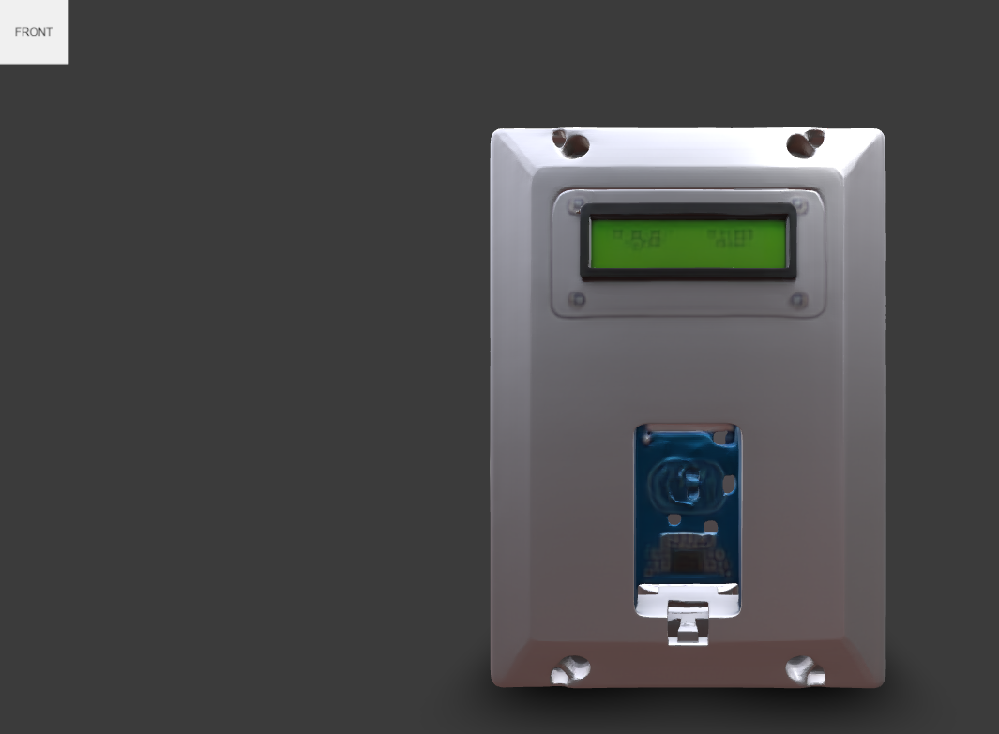
SIDE VIEW OF MACHINE:
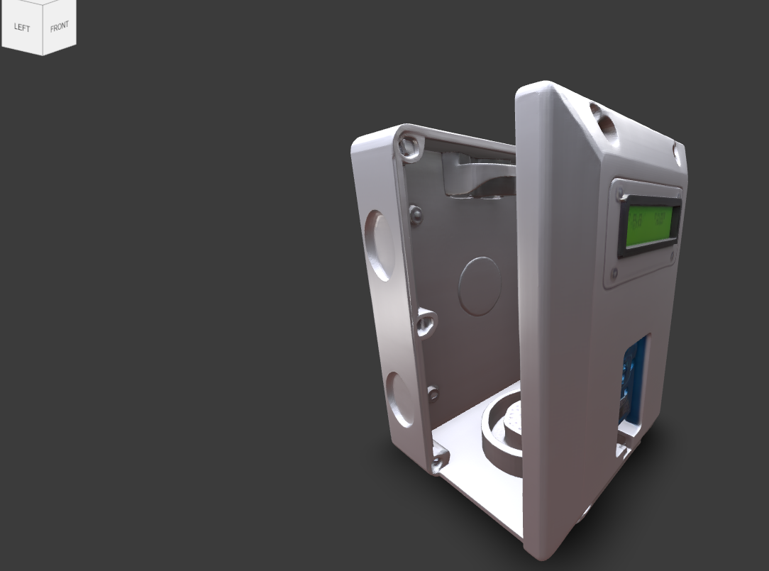
BACK VIEW OF MACHINE:
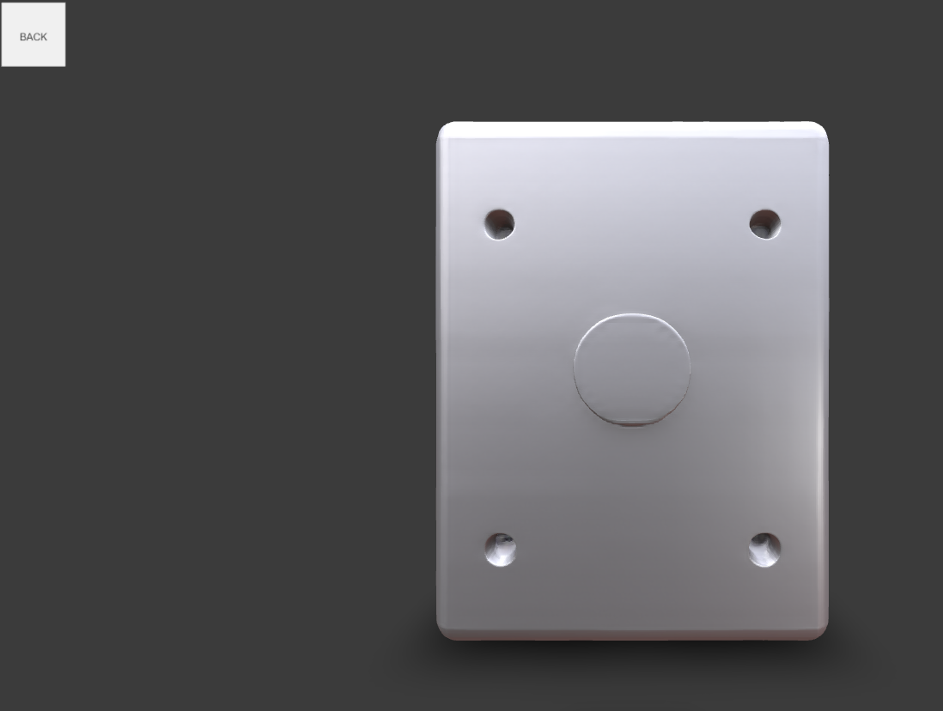

CIRCUIT ASSEMBLY INSIDE THE DEVICE:
